RECOMMENDED FOR
ages 14 to 18; years 9 to 12
RIVER STONE by Rachel Hennessy
ISBN: 9781925227499
YA Fiction | MidnightSun Publishing

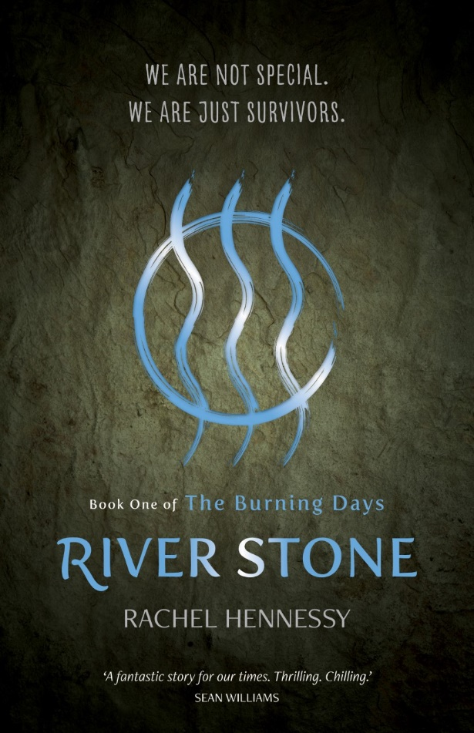
KEY LEARNING AREAS
English, History, The Humanities
GENERAL CAPABILITIES
Literacy (examination, context, creation)
Creative and Critical thinking
Ethical Understanding
Personal and Social Responsibility
REASONS FOR STUDYING
• Examination of speculative fiction, providing an Australian example of a currently popular genre
• Provide a discussion point about environmental degradation, including conservation and animal representation and extinction
• Provide a discussion point about issues of personal and social responsibility, including mantras/mottos
• Encourage imaginative writing and world building
• Analyse style, character, point of view, symbols and plot

SYNOPSIS
Pandora, of the River People, wants so much more than her village can provide. When disaster comes into her life, Pan has the opportunity to become a saviour and escape her pairing with life-long friend Matthew. She wants to make her own choices. But, as she comes to realise, making your own choices also means making your own mistakes …
A story of confused love, difficult friendships and clumsy attempts at heroism, Pan’s fight for her village will bring her into contact with a whole new world, where the truth about the past will have terrifying reverberations for her people’s future survival.
www.midnightsunpublishing.com
www.rachelhennessyauthor.com
To arrange a school visit, call
0400 047 426 or email
anna@midnightsunpublishing.com
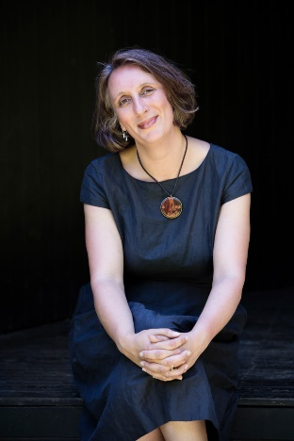
ABOUT THE AUTHOR
Rachel Hennessy is the award-winning author of two novels of contemporary fiction: The Quakers (Wakefield Press, 2008) and The Heaven I Swallowed (Wakefield Press, 2013). Her first novel, about a group of obsessive teenagers, was described by John Birmingham as ‘un-put-down-able’ and was winner of the Adelaide Festival’s Best Unpublished Manuscript Award. Her second novel was Runner Up in the Australian/Vogel Award, long-listed for the Nita B Kibble Award and described by Australian Aboriginal Studies as ‘an important book’. Rachel lives in Melbourne with her partner and their two young daughters.

STUDY GUIDE
Written by Rachel Hennessy. Thank you to teachers Barbara Davis and Kate Lamason for their advice and feedback.
The following notes provide a variety of questions, discussion points and activities that can be used with the novel River Stone. These activities are suited to a range of ages, learning style and ability levels.

Style
The book is written in an accessible style, with a strong mix of action, romance and exploration of ideas. It is set in a country resembling Australia, but with a clear sense of the differences wrought by time. The opening of the book includes an exchange of unattributed dialogue:
‘But if there were so few humans left, why did they not stay together?’
‘Because they chose not to.’
‘And why did they choose not to?’
‘Because they were human.’

Questions
·Why do you think the author included this exchange? What expectations does it give you of the book you are about to read?
·Do you expect to find out who has spoken these words?
Character
The central character is Pandora (shortened to Pan) who we first see on the day of her ‘Blossoming’, when she turns seventeen. Shortly after, she has to leave the village for the first time. Before leaving, she questions her own strength and ability to cope.
Questions
·How would you describe Pan’s character? Is she strong or weak? Can you find evidence to support either position?
·What kind of relationship does Pan have with her friends, Fatima and Matthew? How is she different from them?
·How important is it to like the central character?
Point of View
The novel is mainly told from Pan’s perspective. The other point of view the novel uses is Pan’s mother, Zaana, who writes letters to her absent daughter. She does so because she has never told her daughter about her past and worries that if she doesn’t do this, she might die and Pan will never know her story.
Questions
·What does introducing a different point of view do to the story?
·Did you enjoy having a different point of view or were you keen to get back to Pandora?
·How did hearing Zaana’s story change your view of Pan’s mother from how you had seen her earlier?
·What contrasts can you identify between the way Zaana speaks and the way Pan expresses herself?
Symbols
The river stone features throughout the novel: it is used by Pan to scare away the cougar Bayat is hunting and she then discovers he has kept it. The river itself is also referred to often.
Questions
·What do the river stone and the river come to symbolise in the novel?
·Can you find the times when Pan thinks of home and her former life in the village? How often does the river figure in these memories?
·How do these symbols help to reveal the way Pan and Bayat think?
Plot
The book can be described as a ‘quest’ story, where the hero/heroine has to go on a journey to fulfil a task that will save those who are important to them. On the way, they learn about their own strengths and weaknesses.
Questions
·What do you think Pan has learnt about herself by the end of the novel? How has she changed (or not)?
·What about the other characters (Fatima, Matthew, Titus, Bayat, Emmaline and Oyan)? Do they change or do they remain the same?
·What other quest stories do you know?
·How is a quest story different from an adventure story?

TEXTS IN CONTEXT
Speculative fiction: Imagining the future
EXTRACT (Chapter 4)
My father had told me, in whispered conversations after my mother has fallen asleep, of how there were many, many, many people before The Burning. We had once been called The Great Southern Land, until the waters rose and we were no longer great and the continents shifted and we were no longer south. So we became simply the land, names were no longer important in our isolation. He once used the word ‘thousands’ to describe how many people there were but when he saw the confusion on my face, he changed it to ‘many, many, many’. The use of the word three times made me think of our village with three times the amount of us. I know this is not nearly enough, but I find it hard to imagine such abundance … Since I’ve known of the possibility, I have dreamt of it, of finding some other place out there, with more survivors. The many, many, many.
River Stone reduces the human population down to a small number of survivors and imagines having to return to a village lifestyle. It is an example of speculative fiction, which asks the question ‘What if…?’ That is, what if there were so few people left in the world that we had to live in small villages and be told who we had to be with, and breed with?

Questions and discussion points
·Discuss the imagined future world of River Stone. How is it different from the world you live in today?
·How would you feel living without technology?
·What kind of life would you prefer: hunting and gathering or being able to go to a supermarket? How difficult would it be to have to spend all your days committed to finding or raising food?
·What would it be like to not have ready access to medicine?
·What would it be like to not have any choices? To be told who you are going to be with?
Many speculative fiction writers explore the idea of ‘what if’?:
Brave New World (1932) by Aldous Huxley – what if all reproduction was artificial and controlled by the state?
Z for Zachariah (1974) by Robert C. O’Brien – what if you were left behind after a nuclear holocaust?
The Handmaid’s Tale (1984) by Margaret Atwood – what if the United States of America became a religious dictatorship?
The Hunger Games (2008-2010) by Suzanne Collins – what if young people had to fight one another on national television?
Activities
Informative writing
1. Ask students to create two columns: “Now” and “Then”. Under a number of subheadings – food, dress, weather, technology, animals, plants, reproduction and family – ask them to write about how things are now and what they imagine things might be in the future.
2. Take one of these topics and write in detail on it, using the ‘What if?’ prompt. For example, what if there were no vegetation, how would humanity survive? How do you imagine life being changed by one difference? Think about the consequences of these shifts and changes to our current way of life.
3. Write an informative piece about this new world, as if you are explaining to an alien who has just arrived on earth.

ENVIRONMENTAL ISSUES
Conservation
At the end of River Stone, the author includes the following note:
The Nature Needs Half movement, established in 2009, believes we can stop the sixth mass extinction event we are currently heading towards if we protect approximately 50% of each of the 846 eco-regions that provide habitat for all of Earth’s biodiversity. For more information go to www.natureneedshalf.org

Questions and discussion points
·What is the Nature Needs Half movement?
·How realistic is it to conserve half the planet for species-other-than-humans?
·What other strategies are being used to protect biodiversity?

Activities
Discursive writing
1. Students choose a wild animal they are interested in. Have them research the status of this animal (secure, threatened, endangered etc.)
2. Write a letter to an individual animal, telling them what is happening to its species, and why. How would an animal understand human concepts like ‘habitat’ and ‘conservation’? How could these terms be put into words which ‘make sense’ to a non-human animal?
3. The students swap letters and write the return letter, told from the perspective of the animal, considering how an animal might feel finding about what is happening to their species.
4. How did putting themselves into the mind of the animal make them feel? Did it help to see both sides? Did writing from the animal’s point-of-view feel strange or did it help to create empathy?
Animal Representation
EXTRACT (Letters 3)
There it was, as we turned off the main avenue towards the bridge, flashing in orange and white neon, the sign of the tiger stalking across the top of our white edifice, an animal I had never seen in the flesh, since it was extinct by the time I was born. I remember Hector squeezing my hand tightly as we drove past it. I kept my face turned away from his so he couldn’t see me crying.
River Stone imagines a time when many animals critically endangered today have become extinct.
Questions and discussion points
·What would it mean if the top predators (lions, tigers, bears) no longer existed? How would this effect our environment?
In River Stone the Kaplan Company uses the tiger as its symbol.
·What does using an animal representation for a business do for that animal? Read out the following quote:
‘A recent paper from researchers in France identified the most popular ‘charismatic’ animals: tigers, lions, giraffes, elephants, leopards, panthers, cheetahs, pandas, polar bears, gorillas and wolves. All of them are at high risk of imminent extinction in the wild but most of the people the researchers talked to had no idea. Why? Because they see so many images of these animals – as toys, on hoodies, in ads for insurance, as mascots for international games, in nature documentaries – that they assume the planet is full of them.’ (Jane Rawson, Meanjin, Vol 77, Issue 3, 2018)
A recent initiative, called The Lion’s Share ( https://thelionssharefund.com/ ) tries to address this issue. Each time a campaign uses an image of an animal, the advertiser will donate 0.5% of the paid media spend of that campaign to The Lion’s Share Fund. In partnership with the United Nations Development Programme, The Lion’s Share Fund will then disperse that money across the world to wildlife, conservation, and animals in the greatest need.

Activities
Persuasive writing
1. Research advertising campaigns which utilise animals. How has the animal been depicted (photograph, animation etc.)? How connected is the animal to the product (if at all)? Why do you think the animal has been used by the company?
2. Have students re-design the advertising campaign without the use of an animal. What difference did it make? What did the campaign gain or lose from not utilising an animal representation?

Animal hybrids
EXTRACT (Chapter 15)
If I had tried to imagine what the creatures looked like, what the ferals were going to be, it wasn’t anything like the female face which now glared at us around the corner of the wall. Her hair was short and white, matted onto her head, and her skin was a weird, mottled orange. She stared, her eyes also orange, with thin black vertical lines in their centres.
She slinked around the corner, her short, dirty dress showing her legs to be the same strange colour. Other than the eyes and the hue of her skin, she looked just like all the other human beings I’d ever seen in my life which, I admit, isn’t that many. She seemed to be walking normally, only a bit slowly, cautiously padding towards us.
I’d expected some kind of clear deformity, something to make them distinctly not-like-us. This was a human being changed, yes, but still … human?

The creatures in River Stone, called ‘ferals’ seem to be a hybrid of human and non-human animals. Pan spends time questioning what it is that makes them not-human and, by implication, what is it that makes us human.
Questions and discussion points
·What kind of creatures/monsters did you expect the group to find in the abandoned city?
·What makes an animal different from a human?
·What are the boundaries between animal-ness and humanity?
·Can you think of other monsters used in literature to draw attention to the nature of humanity?

Activities
Informative writing
1. Choose a monster (zombies, vampires, chimeras etc.) that features in literature or films.
2. Research the first instance of this monster in a cultural product and look at the different ways in which it has been represented over time since.
3. Create a timeline, with pictures if necessary, to show how this monster has changed over time, looking at what it represents now, as opposed to hundreds of years ago.
4. Consider what makes it a monster and why it is scary or abhorrent to human beings.

PERSONAL AND SOCIAL RESPONSIBILITY
Mottos and mantras
The River People use the motto/mantra ‘We are not special. We are just survivors’ to remind themselves of their luck in surviving The Burning, and to stop them from an unfounded belief in their unique-ness.
Mantra = a word or sound repeated to aid concentration in meditation/a statement or slogan repeated frequently
Motto = a short sentence or phrase chosen as encapsulating the beliefs or ideals of an individual, family, or institution

Questions and discussion points
·What is the purpose of a motto/mantra? How does repeating something add to its effectiveness?
·Is it a good idea for the River People to not think of themselves as ‘special’?
·What is the difference between individual versus community mantras/mottos?
·What is the difference between a mantra and a motto?
·What is the difference between a mantra and an advertising slogan?
·Throughout the novel, Pandora is considering what her village wants from her, compared to what she wants for herself. Is the individual’s desires more important than the community’s? Should romantic love be the most important value?

Activities
Reflective writing
1. Think of examples of mantras (eg. “Think local, act global”) and mottos (eg. “Be Prepared” by the Scouts) and advertising slogans (eg. “Just. Do. It” by Nike). What is the school’s motto (if it has one)?
2. Have students discuss their beliefs and values. Do the students have a personal mantra? How can it be used to reinforce positive ideas about themselves? How does it connect with what the school community expects of them?
3. Create mottos for your family/your school/your sporting club/your activity which encapsulates that community’s beliefs and ideals.
4. Write a reflection on these mottos. What choices did they make in terms of language? Did they use formal or colloquial/everyday language? Is a shorter motto a better motto? Can the motto be in another language (for example, many schools still have their mottos in Latin)? What is the effect of using another language?
4. Write out their personal mantra. Run a guided meditation session (utilising the Smiling Minds site: https://www.smilingmind.com.au/ ) where they repeat their personal mantra throughout the guided meditation.

CREATING LITERATURE
Re-drafting and Openings
The following is the first draft of the book’s opening paragraph, written in 2015:
EXTRACT (first draft of opening paragraphs)
I wake, knowing this could be the worst day of my life, or the very best. For twelve cycles of the moon, I’ve waited for today, the beginning of the year of my Blossoming, the beginning of the year when everything changes.
I sit up and feel the cold air. The sun hasn’t risen yet. Through the smoking hole of our hut, I catch a glimpse of grey sky, the last of the night’s light. The blanket on which I lie has only a touch of damp and has kept me warm during the dark hours. I know I’m lucky to have a thick one which has survived the ravages of time. My friend Matthew complains about the thin, ragged state of his.
I look up at the hairline crack in the mud-brick, running from halfway up the wall to the chimney, the same crack I’ve been waking up to for as long as I can remember.

Compare this to the first paragraphs of the published version.
EXTRACT (published version of opening paragraphs)
‘Hold still,’ Theodore whispers and I close my eyes.
I try not to tense, to anticipate the pain. My father has talked to me about staying relaxed throughout, to make it hurt less. I can feel Theodore behind me, the heat of the carved river stone in his gloved hand.
I bite my lip as the stone sears into my shoulder blade. By the rivers, it hurts … but I don’t cry out. I squeeze my hands tightly together, forcing myself to stop the tears threatening to fall.
The circle and the three waves are being branded into my skin. I smell the scorched flesh but still I don’t move, don’t flinch away from the rock becoming one with me. In my mind I see the cool water, the beautiful clear stream I love. I imagine myself diving into that pool. I swim to the bottom, to the sandy bed where the river stones shimmer like silver.

Questions and discussion points
·How has the writing changed? Why do you think the author changed what was happening in the opening?
·What makes an interesting and engaging opening to a story?
·What makes you want to keep reading?
·How important is what is happening (plot) compared to who is doing it (character) or where it is happening (setting)?
·What role does language play?
Activities
Critical and creative thinking
Look at the following opening paragraphs:
When I wake up, the other side of the bed is cold. My fingers stretch out, seeking Prim's warmth but finding only the rough canvas of the mattress. She must have had bad dreams and climbed in with our mother. Of course, she did. This is the day of the reaping.
The Hunger Games, Suzanne Collins
It was a bright cold day in April, and the clocks were striking thirteen. Winston Smith, his chin nuzzled into his breast in an effort to escape the vile wind, slipped quickly through the glass doors of Victory Mansions, though not quickly enough to prevent a swirl of gritty dust from entering along with him.
Nineteen Eight-Four, George Orwell
There is one mirror in my house. It is behind a sliding panel in the hallway upstairs. Our faction allows me to stand in front of it on the second day of every third month, the day my mother cuts my hair. I sit on the stool and my mother stands behind me with the scissors, trimming. The strands fall on the floor in a dull, blond ring. When she finishes, she pulls my hair away from my face and twists it into a knot. I note how calm she looks and how focused she is. She is well-practiced in the art of losing herself. I can’t say the same of myself.
Divergent, Veronica Roth
·What is the focus of each opening? Character, setting or plot?
·Which of them makes you want to keep reading? Why?
Activities
Imaginative writing
1. Give the students the bare bones of a story. Examples:
a. A family loses their beloved cat. They go in search of it.
b. Trains in the city are at a standstill due to a strike. A teenager urgently needs to get home, but can’t afford a cab. They order an Uber.
c. An 18-year-old is preparing to move out of home. He/she discovers all the boxes they had packed have turned to dust.
d. A young girl discovers an underground cave. With her pet dog, she decides to explore it.
2. In groups, from the basic plot elements provided, sketch out the elements of the story: character, setting and plot. Decide, as a group, how you would structure the story: which plot elements are told first? What role does memory play? How does the story end?
3. Individually, write the opening paragraph of the story.
4. Read out loud the different versions of the group. Which version grabbed the students the most? Why? Consider language and the three types of opening focuses: character, setting or plot.

